- List containing int, String and double

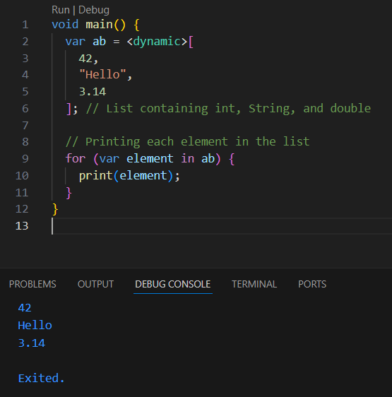

- Create a list: ab contains mixed data types (int, String, double).
- Loop through the list: The for-in loop prints each element.

2,Printing the length of the list

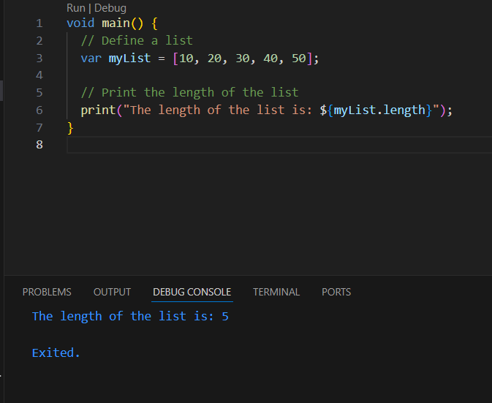

- Define a list:
myList is a list containing integers [10, 20, 30, 40, 50, 89].
- Get and print length:
myList.length gets the number of elements in the list, which is printed using print().

3,Nested list

A nested list in Dart is a list that contains other lists as its elements. It allows you to create multi-dimensional data structures, such as a 2D or 3D list.
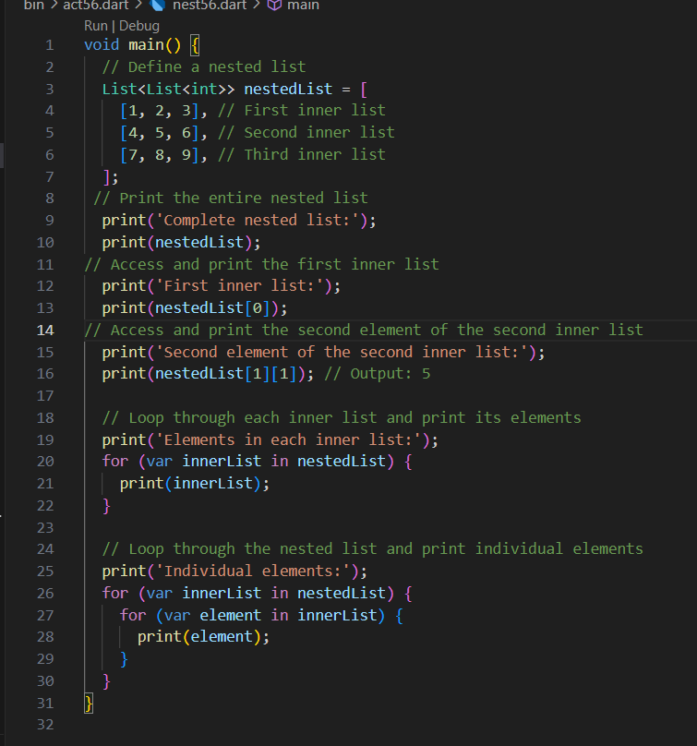

- Define a nested list:
1,A 2D list nestedList contains three inner lists.

- Print entire list:
1,Prints the full nestedList.

- Access specific data:
1,Print the first inner list using nestedList[0].
2,Print the second element of the second inner list using nestedList[1][1].
- Loop and print:
1,Print each inner list.
2,Print each individual element using nested loops.

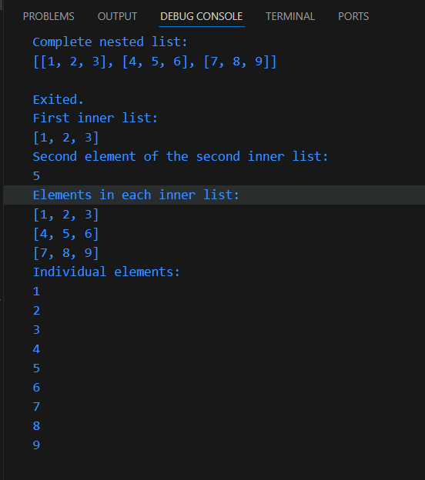

4, Adding and removing values in list, if conditions, nested list

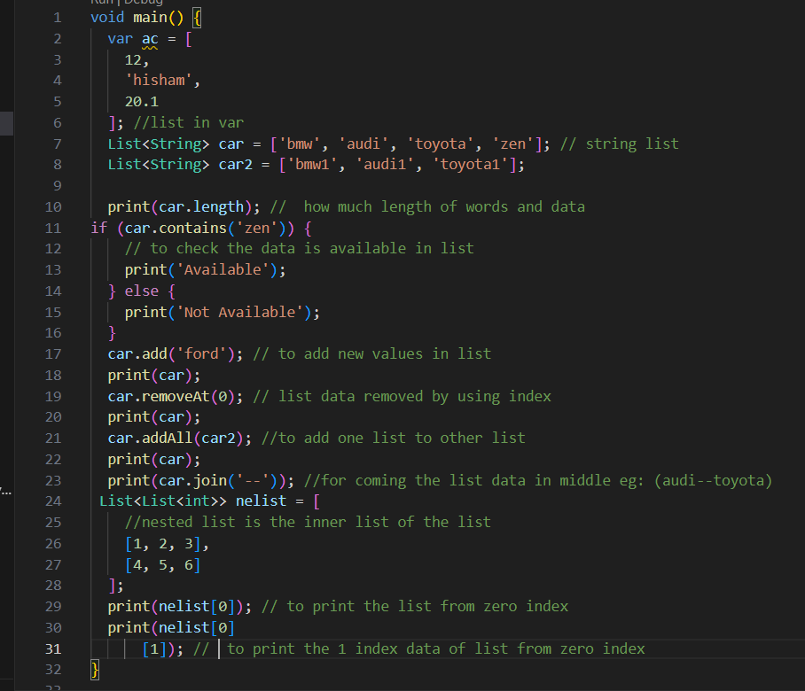

- List Definition:
- ac: A list containing mixed data types (int, String, double).
- car and car2: Lists containing car names (strings).

- Length of List:
- car.length: Prints the number of elements in the car list.

- Check if Item Exists:
- car.contains('zen'): Checks if 'zen' is in the car list. It prints Available if true, otherwise Not Available.

- Modify List:
- car.add('ford'): Adds 'ford' to the car list.
- car.removeAt(0): Removes the item at index 0 from the car list.
- car.addAll(car2): Adds all elements of car2 to car.
- car.join('--'): Joins the elements of car into a single string, separated by '--'.

- Nested List:
- nelist: A 2D list with two inner lists.
- nelist[0]: Prints the first inner list.
- nelist[0][1]: Prints the second item of the first inner list.

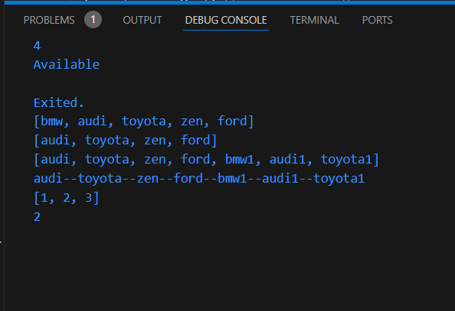

5, Map
To print the key and value separately and together from a Map

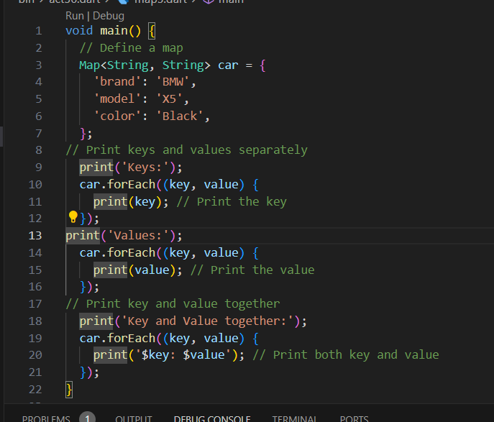

- Map Definition:
A Map named car stores car details with keys like 'brand', 'model', and 'color'.
- Print Keys:
Loop through the map and print each key (e.g., 'brand', 'model').
- Print Values:
Loop through the map and print each value (e.g., 'BMW', 'X5').
- Print Key and Value Together:
Loop through the map and print each key and value together (e.g., 'brand: BMW').

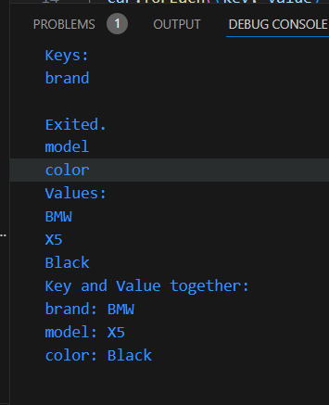

6,Set in dart
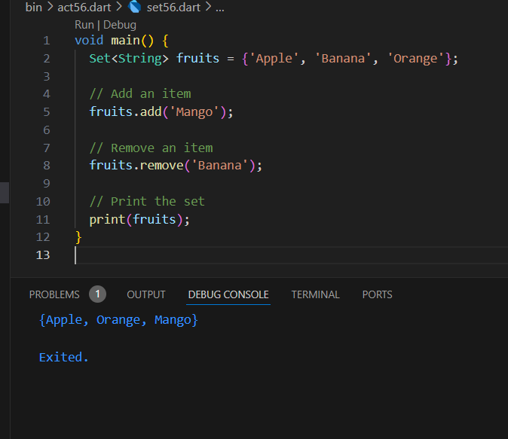

- Create a Set: A Set of fruits is created with 'Apple', 'Banana', and 'Orange'.
- Add: 'Mango' is added to the set.
- Remove: 'Banana' is removed from the set.
- Print: The set is printed.

